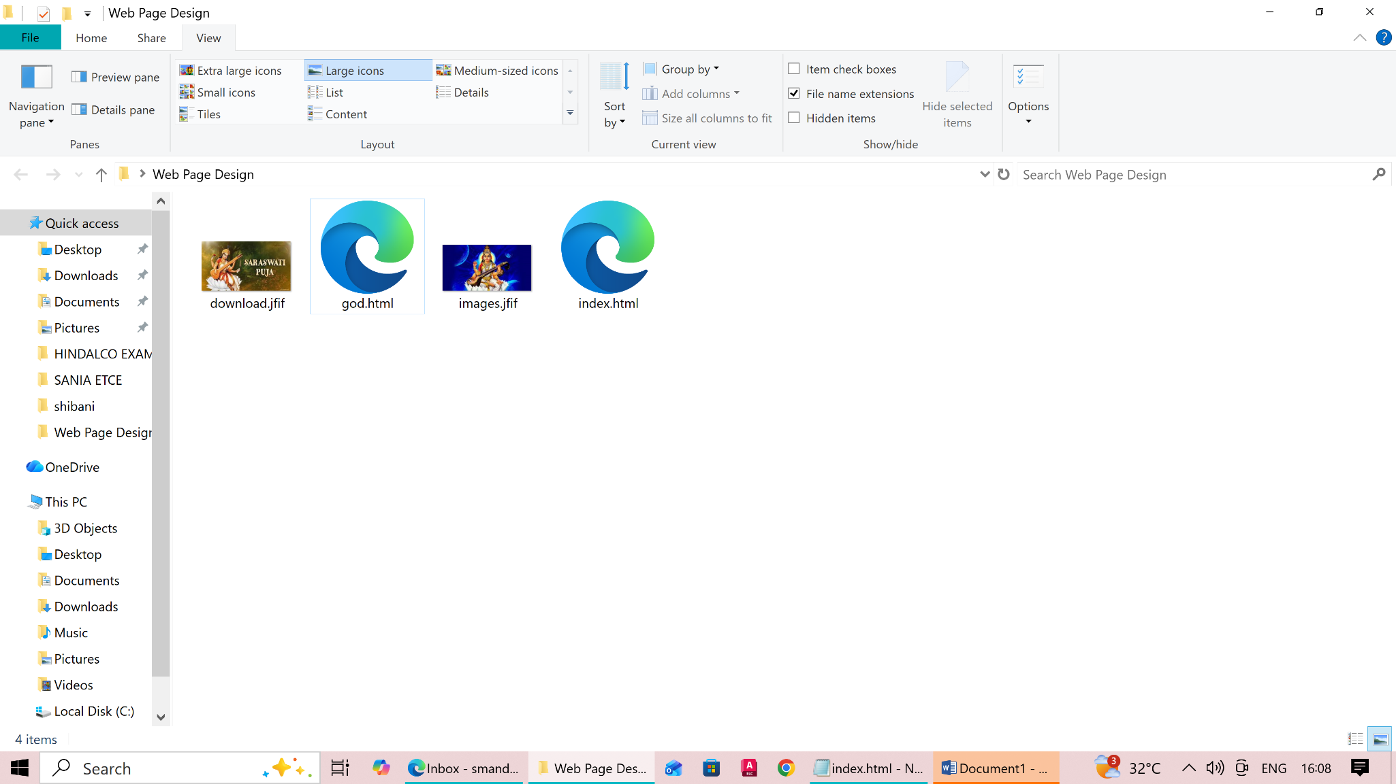
Structure:

File Name:index.html
<html>
<head>
<title> Home Page</title>
</head>

<body>
<h1 align="center">Welcome to Purulia Polytechnic</h1>
<a href="god.html">Goddes Saraswati</a>
<br>
<a href="https://google.com">Google</a>
<br>
<a href="https://facebook.com">facebook</a>

</body>

</html>

File Name: god.html

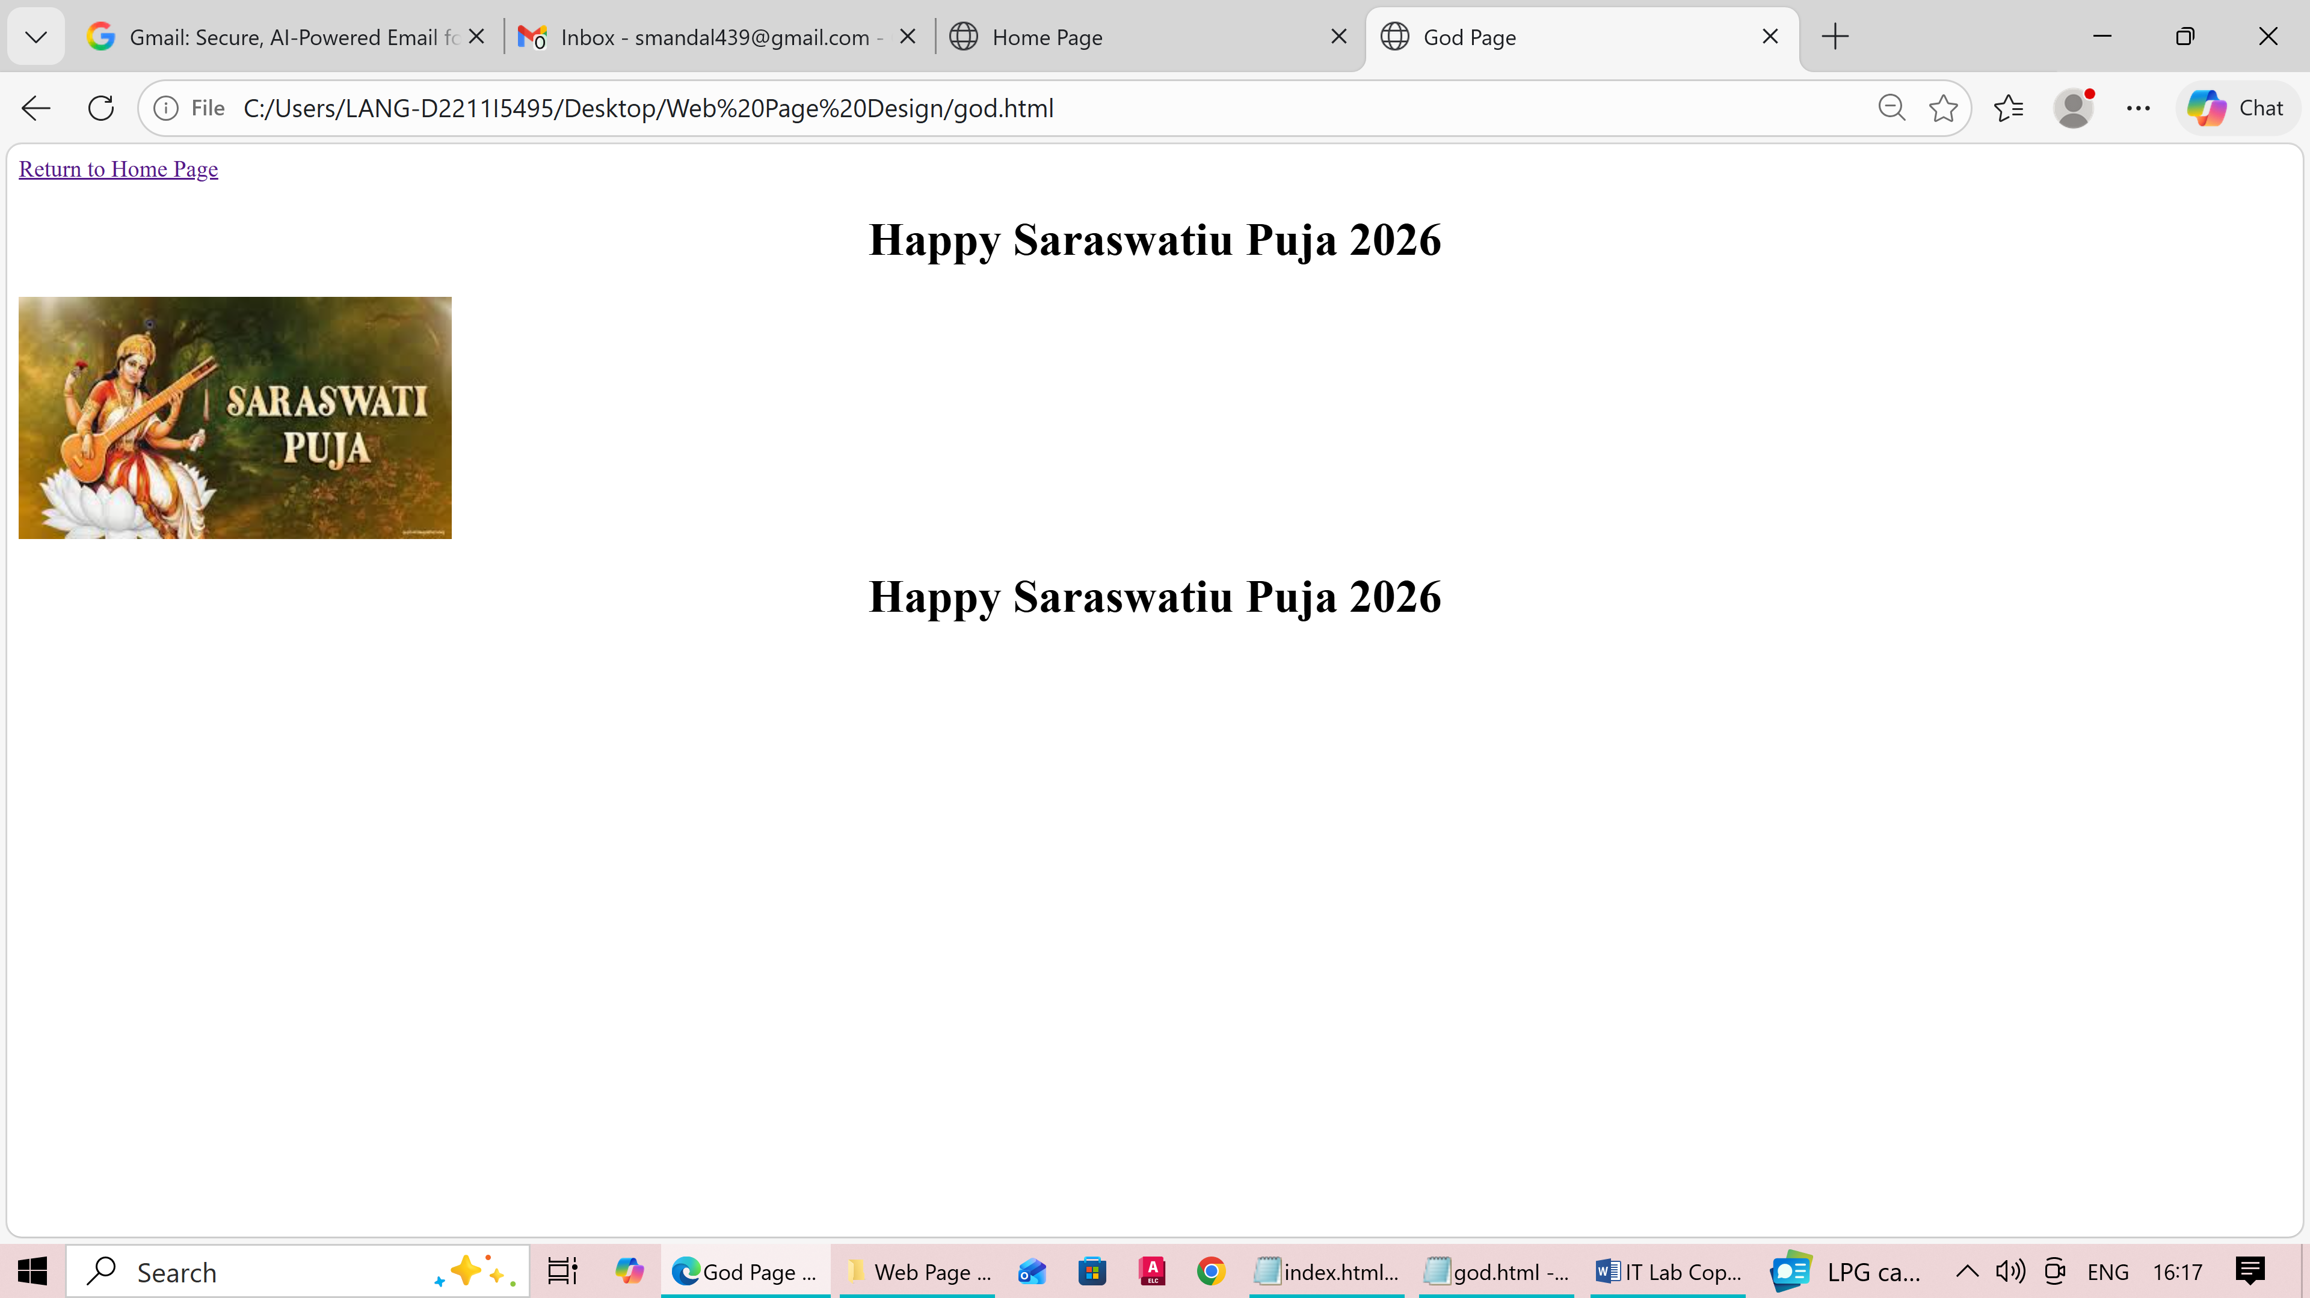
<html>
<head>
<title> God Page</title>
</head>
<body>
<a href="index.html">Return to Home Page</a>
<MARQUEE DIRECTION ="RIGHT" scrollamount="20">
<h1 align="center">Happy Saraswatiu Puja 2026</h1>
</MARQUEE>

<img src="download.jfif"></img>

<MARQUEE DIRECTION ="LEFT" scrollamount="20">
<h1 align="center">Happy Saraswatiu Puja 2026</h1>
</MARQUEE>
</body>
</html>

